**Main types of neural network**

* **Feed-forward neural networks**

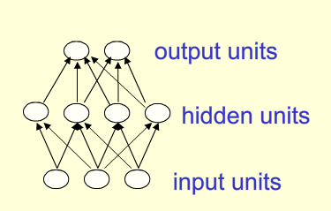

* Deep net --- more than one hidden layer
* Activity(above layer) = non-livear Funct(activity of layer below)
* **Recurrent network**

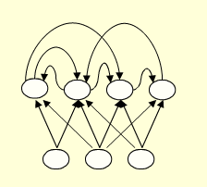

* Difficult to train
* “==” Deep nets with one hidden layer per time slice
* “But” Use the same weights at every time slice
* “But” Get input every time slice
* **Can remember info in hidden layer for a long time**
* **Symmetrically connected networks**
* Similar to recurrent network
* Connections between units are symmetrical (have the same weight in both directions)
* Easier analyzing
* More restricted (cannot model cycles)
* Without hidden units --- “Hopfield nets”
* With hidden units --- “Boltzmann machines”
* More powerful than “Hopfield nets”
* Less powerful than recurrent neural nets
* Simple learning algorithm

**Perceptrons:First generation of nn**

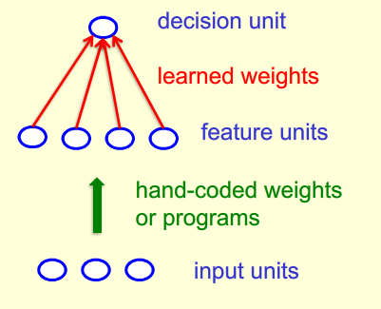

* **Binary threshold neurons**

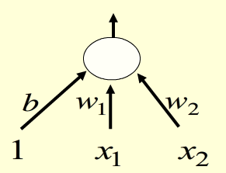

* Weighted sum of inputs from other neurons



* 
* Learning biases use the same rule as learning weights
* Convergence:find weights that get right answers for all trainning cases
* If the output unit is correct,dont change the wieght
* If the output unit is incorrectly outputs 0, add inputs vector to the weight vector
* **Limitations of perceptrons**
  + Once the hand-coded features determined, there are very strong limitation on what perceptron can learn
  + A binary threshold unit cannot discriminate between different patterns that have same features
    - The tricky part of pattern recognition must be solved by hand-coded features rather than learning procedure

Assignment1:Perceptron

Dataset1

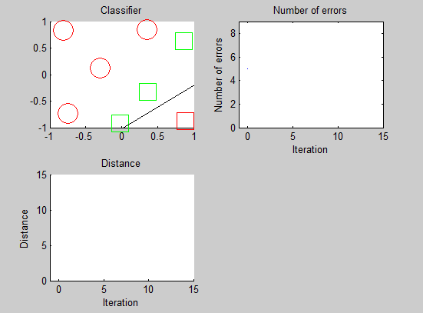

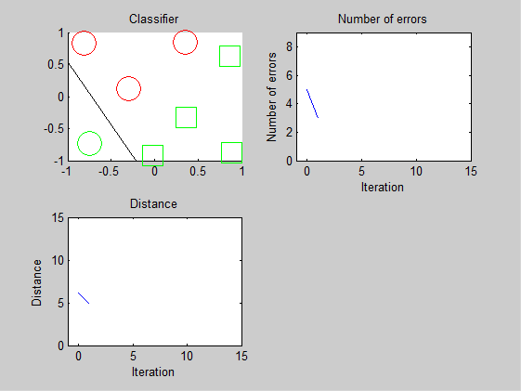

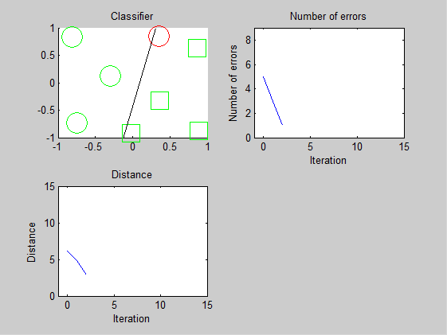

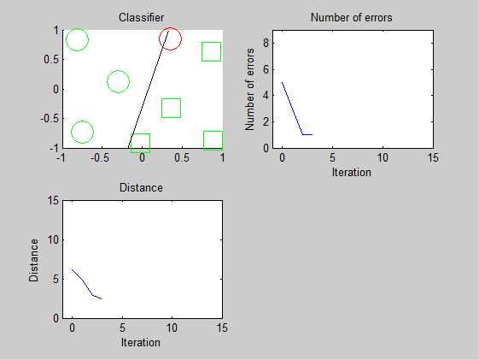

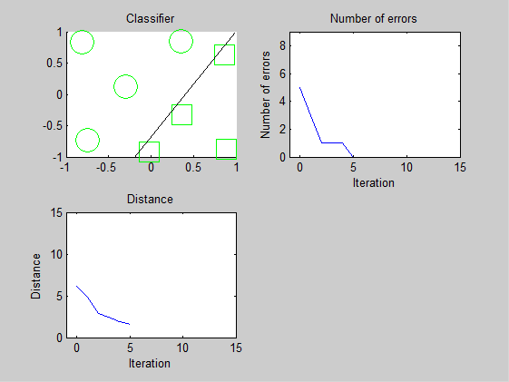

Dataset2

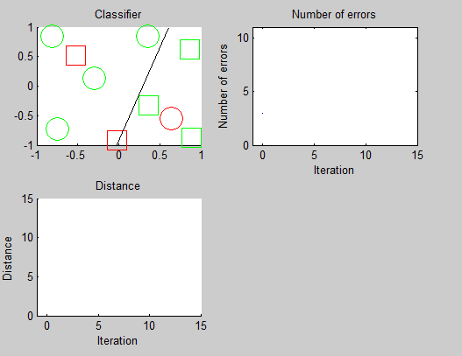

Dataset3

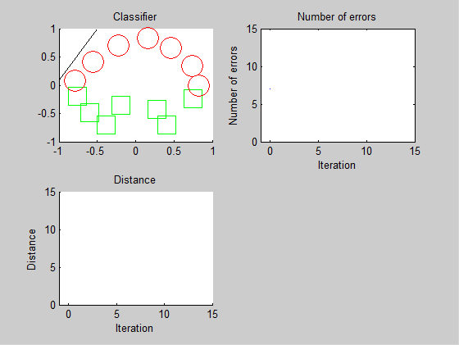

Dataset4

